**Selenium DAY-5**

**EX : 01**

package com.Pack1;

import org.openqa.selenium.By;

import org.openqa.selenium.WebDriver;

import org.openqa.selenium.WebElement;

import org.openqa.selenium.chrome.ChromeDriver;

import org.openqa.selenium.chrome.ChromeOptions;

import org.openqa.selenium.interactions.Actions;

import io.github.bonigarcia.wdm.WebDriverManager;

public class Day5ex1 {

public static void main(String[] args) {

// TODO Auto-generated method stub

WebDriverManager.chromedriver().setup();

ChromeOptions co=new ChromeOptions();

co.addArguments("--remote-allow-origins=*");

WebDriver driver=new ChromeDriver(co);

driver.get("https://demoqa.com/droppable/");

Actions a=new Actions(driver);

WebElement source_ele=driver.findElement(By.id("draggable"));

WebElement dest_ele=driver.findElement(By.id("droppable"));

a.clickAndHold(source_ele).release(dest_ele).build().perform();

a.dragAndDrop(source_ele, dest_ele).build().perform();

}

}

**Output:**

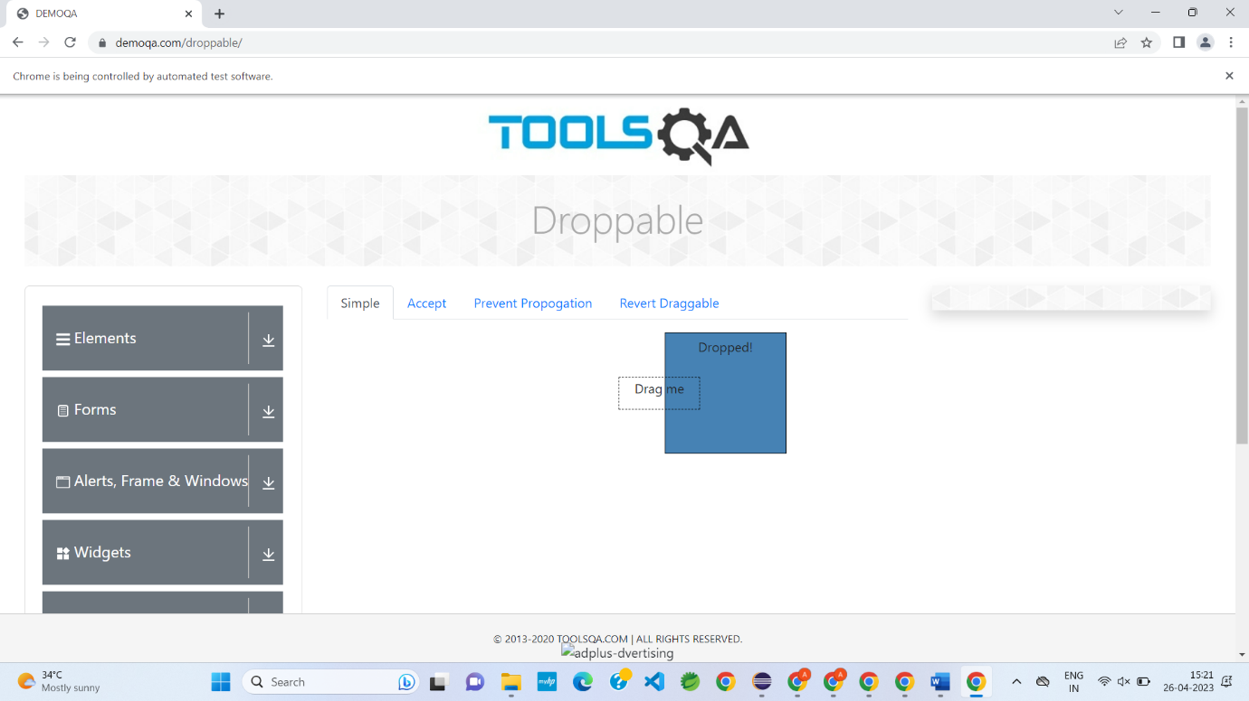

**EX : 02**

package com.Pack1;

import org.openqa.selenium.By;

import org.openqa.selenium.WebDriver;

import org.openqa.selenium.WebElement;

import org.openqa.selenium.chrome.ChromeDriver;

import org.openqa.selenium.chrome.ChromeOptions;

import org.openqa.selenium.interactions.Actions;

import io.github.bonigarcia.wdm.WebDriverManager;

public class Day5ex2 {

public static void main(String[] args) throws InterruptedException {

// TODO Auto-generated method stub

WebDriverManager.chromedriver().setup();

ChromeOptions co=new ChromeOptions();

co.addArguments("--remote-allow-origins=*");

WebDriver driver=new ChromeDriver(co);

driver.get("https://jqueryui.com/droppable/");

driver.switchTo().frame(0);

Thread.sleep(3000);

Actions a=new Actions(driver);

WebElement source_ele=driver.findElement(By.id("draggable"));

WebElement dest_ele=driver.findElement(By.id("droppable"));

a.clickAndHold(source_ele).release(dest_ele).build().perform();

a.dragAndDrop(source_ele, dest_ele).build().perform();

}

}

**Output:**

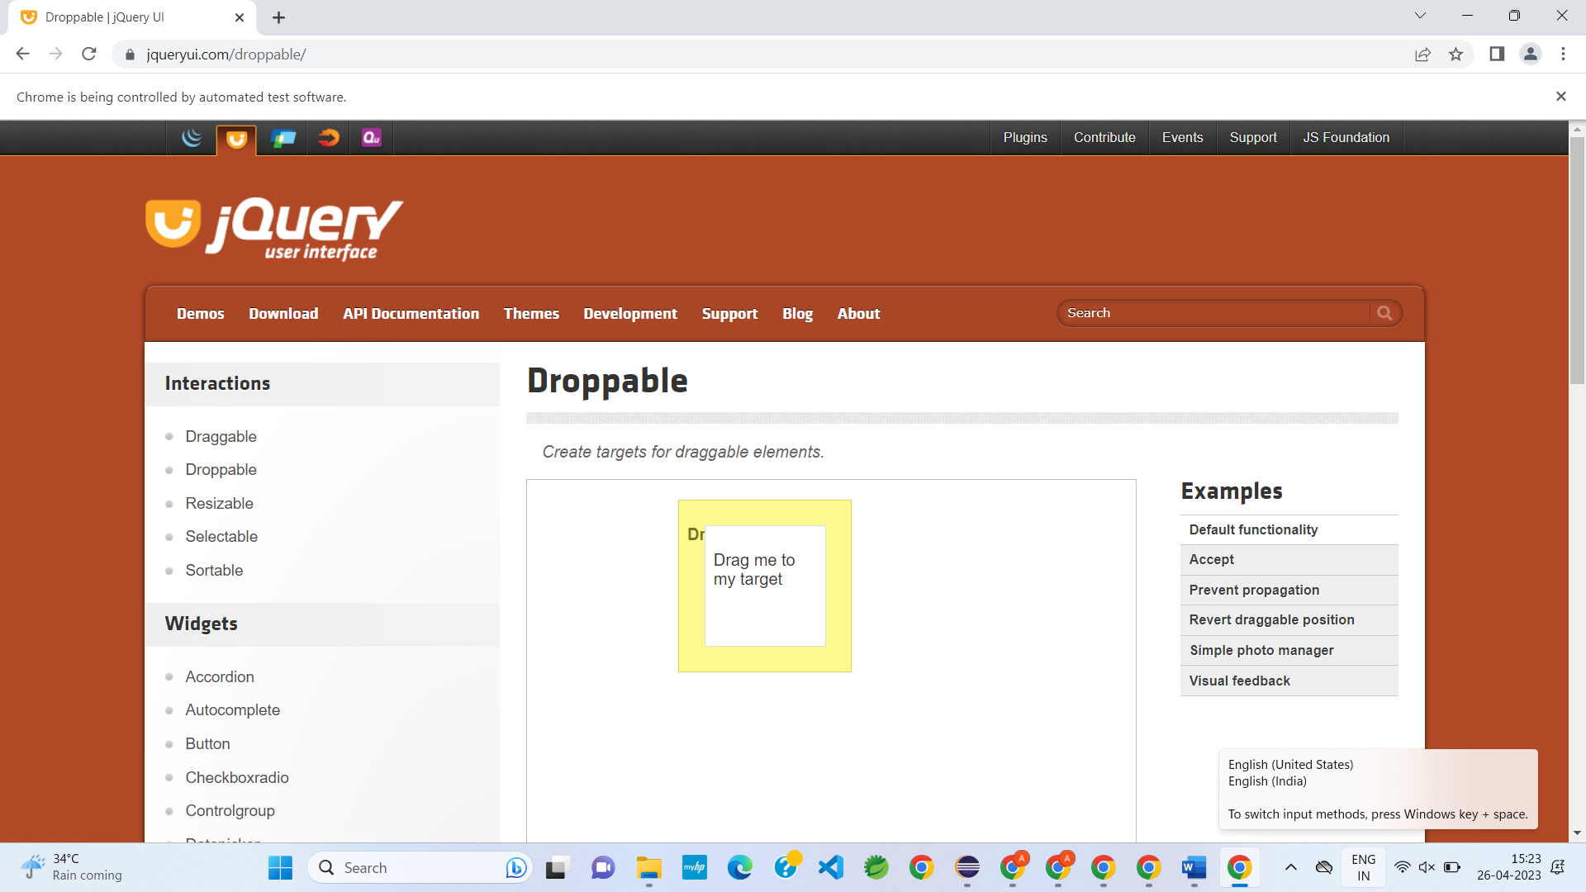

**EX : 03**

package com.Pack1;

import org.openqa.selenium.Alert;

import org.openqa.selenium.By;

import org.openqa.selenium.WebDriver;

import org.openqa.selenium.WebElement;

import org.openqa.selenium.chrome.ChromeDriver;

import org.openqa.selenium.chrome.ChromeOptions;

import io.github.bonigarcia.wdm.WebDriverManager;

public class Day5ex3 {

public static void main(String[] args) throws InterruptedException {

// TODO Auto-generated method stub

WebDriverManager.chromedriver().setup();

ChromeOptions co=new ChromeOptions();

co.addArguments("--remote-allow-origins=*");

WebDriver driver=new ChromeDriver(co);

driver.get("https://demo.guru99.com/test/delete_customer.php");

WebElement txt_box=driver.findElement(By.name("cusid"));

WebElement submit_btn=driver.findElement(By.name("submit"));

txt_box.sendKeys("401");

submit_btn.click();

Alert alert1=driver.switchTo().alert();

alert1.dismiss();

txt_box.clear();

txt_box.sendKeys("402");

submit_btn.click();

Alert alert2=driver.switchTo().alert();

alert2.accept();

Alert alert3=driver.switchTo().alert();

String txt=alert3.getText();

alert2.accept();

}

}

**Output:**

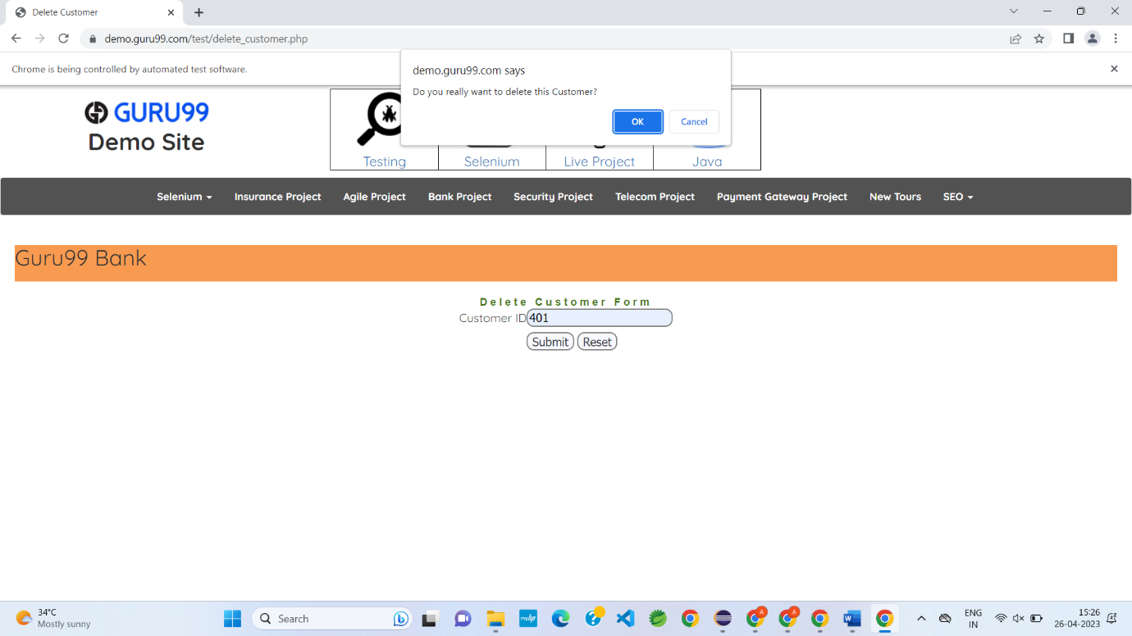

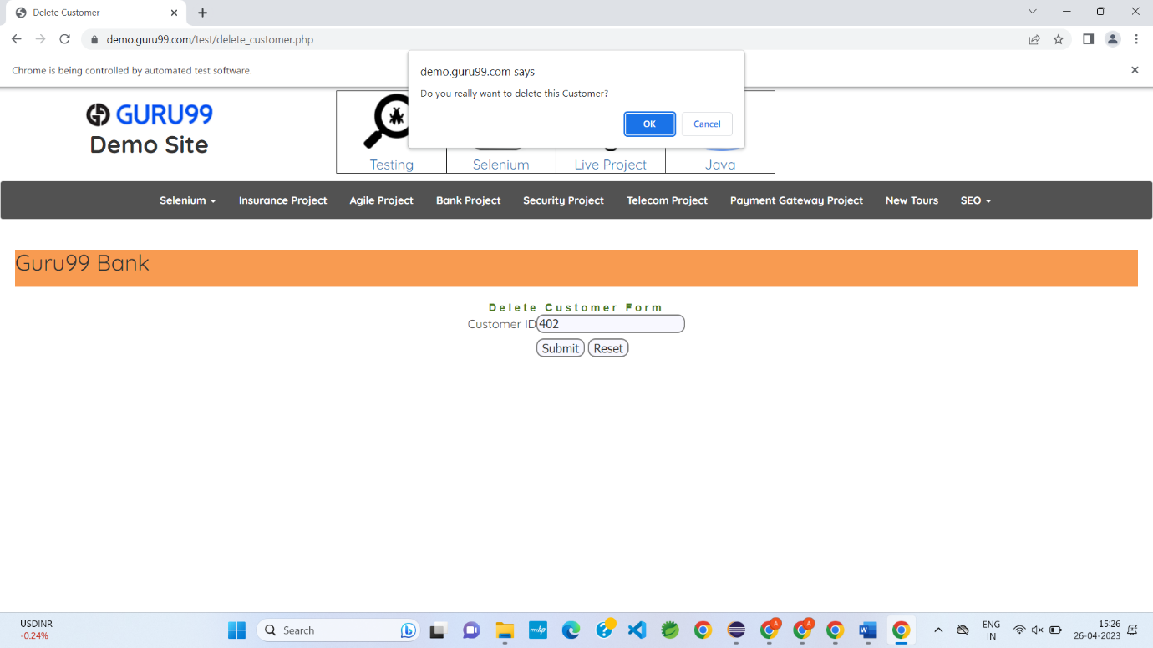

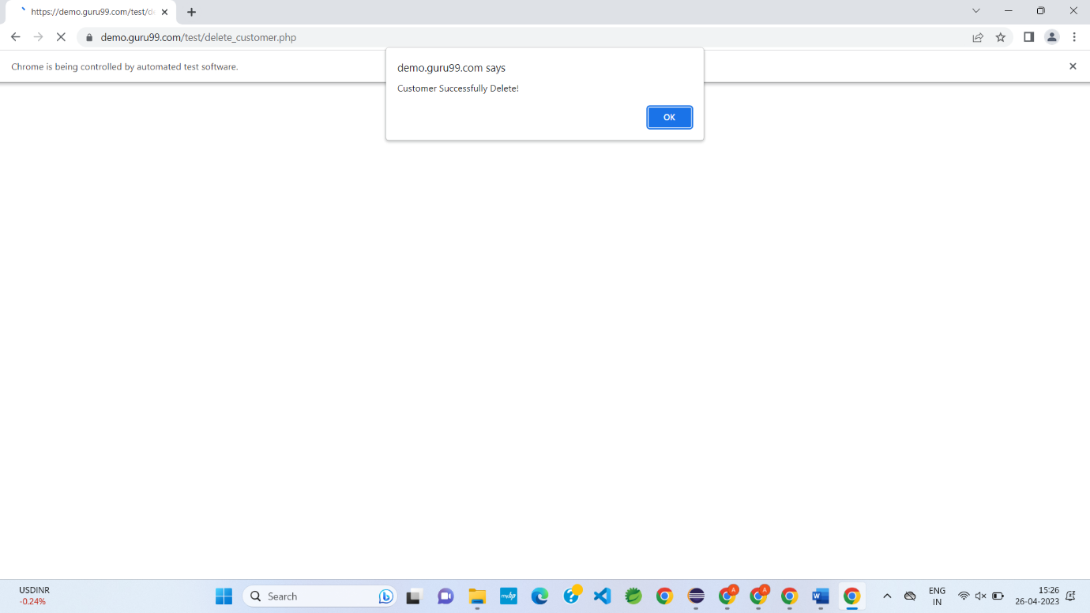

**EX : 04**

package com.Pack1;

import org.openqa.selenium.By;

import org.openqa.selenium.JavascriptExecutor;

import org.openqa.selenium.Keys;

import org.openqa.selenium.WebDriver;

import org.openqa.selenium.WebElement;

import org.openqa.selenium.chrome.ChromeDriver;

import org.openqa.selenium.chrome.ChromeOptions;

import io.github.bonigarcia.wdm.WebDriverManager;

public class Day5ex4 {

public static void main(String[] args) throws InterruptedException

{

WebDriverManager.chromedriver().setup();

ChromeOptions co = new ChromeOptions();

co.addArguments("--remote-allow-origins=*");

WebDriver driver = new ChromeDriver(co);

driver.get("https://www.abhibus.com/bus-ticket-booking");

driver.manage().window().maximize();

WebElement from = driver.findElement(By.xpath("//*[@id=\"source\"]"));

from.sendKeys("Coimbatore");

Thread.sleep(3000);

from.sendKeys(Keys.ENTER);

WebElement to = driver.findElement(By.xpath("//*[@id=\"destination\"]"));

to.sendKeys("Madurai");

Thread.sleep(3000);

to.sendKeys(Keys.ENTER);

WebElement date = driver.findElement(By.xpath("//*[@id=\"datepicker1\"]"));

date.click();

JavascriptExecutor js = (JavascriptExecutor)driver;

js.executeScript("arguments[0].setAttribute('value','02-05-2023')", date);

WebElement search = driver.findElement(By.xpath("//*[@id=\"seo_search_btn\"]"));

search.click();

}

}

**Output:**

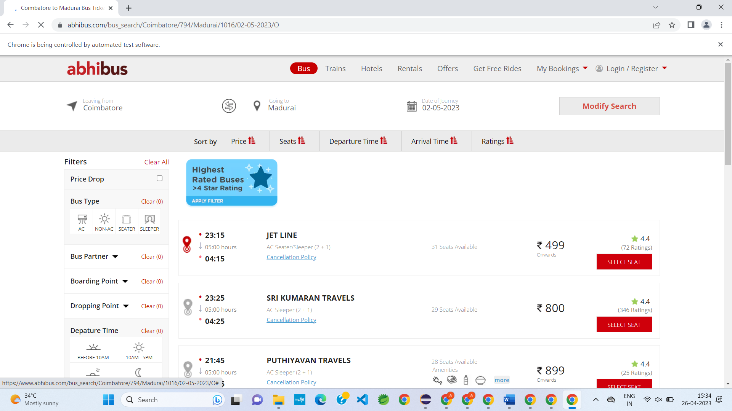

**EX : 05**

package com.Pack1;

import org.openqa.selenium.By;

import org.openqa.selenium.Keys;

import org.openqa.selenium.WebDriver;

import org.openqa.selenium.WindowType;

import org.openqa.selenium.chrome.ChromeDriver;

import org.openqa.selenium.chrome.ChromeOptions;

import io.github.bonigarcia.wdm.WebDriverManager;

public class Day5ex5 {

public static void main(String[] args) {

//System.setProperty("webdriver.chrome.driver","C:\\chromedriver.exe");

WebDriverManager.chromedriver().setup();

ChromeOptions co=new ChromeOptions();

co.addArguments("--remote-allow-origins=*");

WebDriver driver=new ChromeDriver(co);

driver.get("https://www.google.com");

driver.manage().window().maximize();

driver.findElement(By.name("q")).sendKeys("Apple");

driver.findElement(By.name("q")).sendKeys(Keys.ENTER);

String parent=driver.getWindowHandle();

System.out.println(parent);

System.out.println(driver.getTitle());

driver.switchTo().newWindow(WindowType.TAB);

driver.get("https://google.com");

driver.manage().window().maximize();

driver.findElement(By.name("q")).sendKeys("Selenium");

driver.findElement(By.name("q")).sendKeys(Keys.ENTER);

System.out.print("\n"+driver.getWindowHandle());

System.out.println(driver.getTitle());

driver.switchTo().newWindow(WindowType.TAB);

driver.get("https://google.com");

driver.manage().window().maximize();

driver.findElement(By.name("q")).sendKeys("Cucumber");

driver.findElement(By.name("q")).sendKeys(Keys.ENTER);

System.out.print("\n"+driver.getWindowHandle());

System.out.println(driver.getTitle());

}

}

**Output:**

